ENIAC (1946) – Electronic Numerical Integrator and Computer: Beginning of Digital Era; 1st general-purpose electronic digital computer; Developed in US during WW2; Though not AI itself, it paved the way for programmable machines by showing that machines could be built to perform complex computations; It marked the starting point for computational thinking, which is foundational for AI; 1956 Dartmouth Workshop – The Birth of AI: Organized by John McCarthy, Marvin Minsky, Nathaniel Rochester & Claude Shannon; It introduced the term “Artificial Intelligence”; Objective: To find how to make a machine that can simulate every aspect of learning or any other feature of intelligence; Considered official birth of the AI field; Sparked early research in problem-solving, logic & symbolic reasoning; 1960s – 1970s (Symbolic Al & Expert Systems): Early Al focused on rule-based systems that used logic to mimic human reasoning; Example: ELIZA, an early natural language processor; 1980s – Rise of Expert Systems:
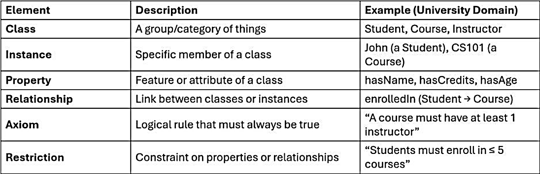
Expert Systems mimicked decision-making of human experts; MYCIN (medical diagnosis), DENDRAL (chemical analysis); Used knowledge bases & inference engines; 1990s – Machine Learning Emerges: Shift from rule-based to data-driven learning; Decision Trees, k-NN, and SVMs gained popularity; Al systems started adapting to data rather than relying solely on logic; 2010s – Deep Learning Breakthroughs: With massive data & computation power, deep neural networks achieved human-level performance in image recognition, speech processing & more; Key technologies: CNNs, RNNs & Reinforcement Learning; Notable moment: AlphaGo beating the
world Go champion in 2016; 2020s – Generative Al Revolution: Generative Al models like GPT, DALL-E & Stable Diffusion emerged; These models generate text, images, music & even code; Built on Transformer architecture & massive language modeling datasets; Widely used in creative, educational & productivity applications; Core branches of AI: Machine Learning (ML); Expert Systems; Robotics; Natural Language Processing (NLP); Deep Learning; Traditional Programming (Rule Based Systems): A programmer explicitly writes rules to process data; Logic is hand-coded (every condition & action must be predefined); System operates strictly based on what has been coded; Choose explicit programming when complete calculation rule is already known (direct programming is transparent & deterministic; a learned approximation is unnecessary); Input + Human-Written Rules = Output; Characteristics: Written by human developers; Flexibility ↓ – must update code to change behavior; Predictability ↑ – same input always gives same output; Learning capability (doesn’t improve w. data); Need to debug step-by-step; AI/ML-Based Systems: machine is given examples of inputs & correct outputs; It learns patterns/rules from the data using algorithms (decision trees, neural networks); Logic isn’t explicitly coded — it is derived from data; Input + Output Data → Learn Rules → Model; Characteristics: Learned from data using algorithms; Flexibility ↑ - adapts to new patterns in data; Predictability moderate – may vary depending on training; Learns & improves w. more data & feedback; Debugging can be done through performance metrics (accuracy, loss); AI Model Development Process: ¹Understand AI task (determine the type of AI task & metrics); ²Gather & preprocess data; ³Choose a model/framework; ⁴Train the model (80% training, 20% testing); ⁵Evaluate & Improve; ⁶Deploy AI (using suitable platforms); AI: Broad field of CS focuses on building systems that can simulate human intelligence; E.g.: Siri; Self-driving cars; Capabilities: Reasoning; Learning; Perception (vision, hearing); Language understanding; Problem-solving; Decision-making; AI → ML → DL → GenAI; ML: Enables computers to learn from data & improve their performance w/o being explicitly programmed for each task; E.g.: Spam filters; Recommendations; Types: Supervised Learning (labeled data): Each training example (input) is paired w. correct output (known target); Goal: To predict outputs for new, unseen data; Classification: Predict categories (spam/not spam); Regression: Predict numerical values (House price); Unsupervised Learning (unlabeled data): Tries to find hidden patterns/structures w/o explicit instructions; Goal: To discover groupings, associations / patterns in data; Clustering: Group similar data points (customer segmentation); Dimensionality Reduction: Reduce number of input variables (PCA); Reinforcement Learning (learning via rewards): Learns by interacting w. an environment & receiving rewards/penalties; Goal: To take actions that maximize cumulative rewards over time (not immediate ones); Concepts: Agent: Learner/decision-maker; Environment: World it interacts w.; Reward: Feedback from environment; Policy: Strategy used to determine next action; DL: Uses multi-layered neural networks to learn from data; E.g.: Face recognition; Voice AI; Characteristics: Can automatically extract features from raw data; Works well w. large & complex datasets; Mimics human brain’s layered structure; Architectures: CNN (Convolutional Neural Networks): Image processing & Computer vision; How it works: Applies filters (kernels) over input images to detect patterns like edges, shapes & textures; These features are then used to identify objects or classify images; Features: Convolutional Layers: Extract spatial features; Pooling Layers: Reduce dimensionality & overfitting; Fully Connected Layers: Perform final classification; RNN (Recurrent Neural Networks): Sequence data (text, speech, time series, sensor signals); How it works: Maintains a memory of previous inputs via loops in the architecture; Updates its state sequentially; They can make predictions based on current input & previous context; LSTM (Long Short-Term Memory): Solves vanishing gradient problem; GRU (Gated Recurrent Unit): Simplified version of LSTM; Transformers: Used in language models (GPT), NLP, Vision tasks; Self-attention mechanism: Allows model to focus on different parts of input simultaneously; Unlike RNNs, Transformers process all tokens in parallel, faster & scalable; E.g.: GPT (Generative Pre-trained Transformer); BERT (Bidirectional Encoder Representations from Transformers); T5, Gemini, Claude, LLaMA; GenAI: Creating new contents using learned patterns from data; Technologies: Transformer Models (GPT-4, Gemini); GANs (Generative Adversarial Networks): Consist of 2 neural networks: Generator: Creates fake data; Discriminator: Detects real vs fake; They compete, improving each other over time; Diffusion Models (DALL·E, Midjourney): Work by adding noise to data & then learning to reverse that noise; Produces ultra-high-quality images & art; Use Cases: Essays, summaries, code; Artwork, illustrations, animations; Enhancing & colorizing old photos; Designing new products/music; Prompt Engineering: Skill of writing clear & effective prompts to get useful results; Prompt: Message/question you give to an AI tool; Greater prompts: Be clear & specific; Mention the style, tone/format you want; Add examples if needed;
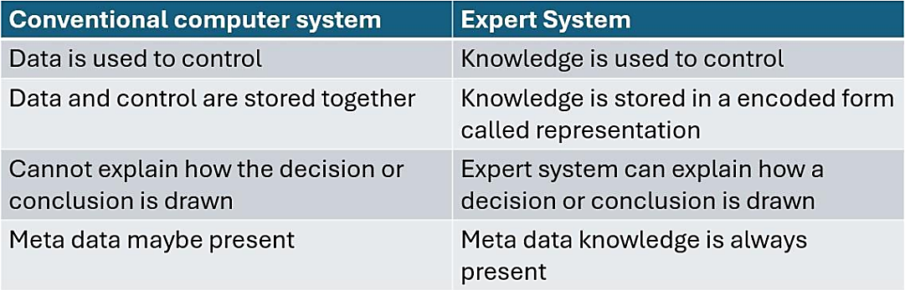
Expert Systems: A type of computer program designed to simulate the decision-making ability of a human expert in a specific domain (like medicine, engineering / finance); It doesn’t think like a human, but it follows if-then rules to reach conclusions based on expert knowledge stored in its system; Data: Raw facts (98.6); Information: Organized data (Temperature = 98.6°F); Knowledge: Meaningful insights (98.6°F is a normal body temperature); Key Components: Knowledge Base: The brain – stores facts & rules collected from domain experts; Types: Declarative (facts): Fever is a body temp > 100.4°F; Procedural (rules): IF fever AND sore throat THEN possible flu; Real-World Example: In a medical expert system, the knowledge base includes disease symptoms, treatment guidelines & diagnostic rules; Inference Engine: The thinker – applies rules to facts; Logical processing unit that applies reasoning to knowledge base to derive conclusions; Forward Chaining (Data-Driven Reasoning): From symptoms → disease; Start with known facts (input data); Apply rules to infer new facts until a goal is reached; How Forward Chaining Works: The system matches facts w. rules; When it finds a rule whose conditions are all true, it fires the rule; The conclusion is added to the known facts; E.g.: Diagnosing Flu Known facts (what the user enters): The patient has a fever, headache & runny nose; Backward Chaining (Goal-Driven Reasoning): From suspected disease → check for symptoms; Start with a goal; Look for rules that support this goal; E.g.: Confirming Flu Diagnosis: Is the patient likely to have flu?;
Feature | Forward Chaining | Backward Chaining
Starts From | Known facts (data) | Goal (hypothesis)
Moves Toward | Conclusions (goal) | Supporting facts (data)
Common In | Monitoring, control systems | Diagnostic & expert advice systems
Example | From symptoms → Find disease | From disease → Check if symptoms fit
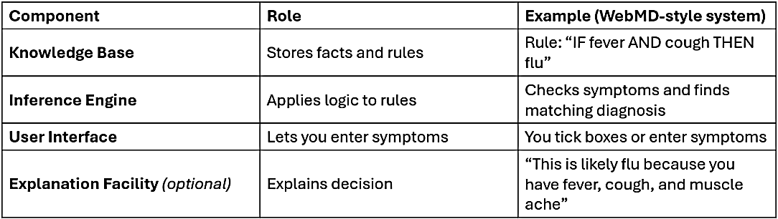
User Interface: Allows humans to interact with the system; Explanation Facility: Explains the reasoning behind decisions & conclusions; Builds user trust & ensures transparency; E.g.: In legal expert systems, the explanation facility shows which laws and facts supported the given legal recommendation; I diagnosed flu because fever + cough were observed; Developer Interface: Helps experts update/improve the system (knowledge); E.g.: Doctors collaborate w. developers to add new disease rules into a medical expert system through a developer interface; Expert systems doesn’t learn by itself, but a developer is needed to update the system; Working Memory/Fact Base: Temporary memory that stores current facts during a reasoning session; Used by the inference engine to track progress of reasoning; E.g.: When diagnosing a patient, working memory stores entered symptoms; External Interfaces (optional): Links to external databases / software programs; Used when expert system needs to fetch live data/send results to other systems; E.g.: In a financial expert system, it might access real-time stock prices/customer account data; Reasoning: Reasoning in expert systems refers to the process of drawing conclusions from known facts & rules; The system uses logical steps to figure out a sol^{n} to a problem; Expert Systems in the Real World: MYCIN (Healthcare): Diagnosed blood infections; DENDRAL (Chemistry): Predicted molecular structures using spectra data; XCON (Computing): Automated configuration of computer systems; HEARSAY (Military/Voice): Voice recognition → submarine sonar detection; Limitations of Expert Systems: Built entirely using manual rules; Hard to keep up-to-date as domains evolve; Can’t learn from data; Breaks easily w. incomplete/conflicting rules; Not scalable to complex problems like vision, language/natural speech; Handles uncertainty poorly compared to probabilistic models; Ontologies: A structured way to represent knowledge, including concepts, properties & relationships between those concepts — in a way that computers can understand & reason with; Organizing knowledge so it’s easy to search, browse & retrieve based on defined relationships; Characteristics: Formal: It follows a specific structure & rules; Explicit: All terms & relationships are clearly defined; Shared: Agreed upon by a group of users/systems; Conceptualization: It reflects how we view a part of the world; Uses: They give meaning to data — machines don’t just see words; they see relationships & structure; They help in reasoning: Infer new facts from existing ones; They make data sharable & understandable across systems; Real-world Applications: Healthcare: SNOMED CT: standardizes medical terms across systems; E-commerce: Amazon’s product categories & filters; Search Engines: Google Knowledge Graph for smart answers; Smart Farming: AgroVoc: crop, soil & weather data links; The Ontology Stack: Structure (semantics/expressiveness); Concepts (classes); Properties (relations, attributes); Entities (objects, values); Supports & improves recommendation algorithms; Challenges: Require domain experts to build & maintain; Best for well-structured knowledge & not suitable for unstructured data like text, images, audio; Limited in capturing uncertainty/probabilistic relationships; Why Move Beyond Expert Systems & Ontologies? Rule-based systems are limited in flexibility & scalability; Ontologies require manual creation & don’t adapt to changing data; Both lack learning capability — they don’t improve w. experience; They struggle w. unstructured, ambiguous/noisy real-world data; Machine Learning (ML): Learns patterns from data automatically; Scales to new problems w/o explicit reprogramming; Powers applications like email filtering, fraud detection; Deep Learning (DL): Uses neural networks to handle complex unstructured data; Excels in image recognition, speech processing, NLP; E.g.: ChatGPT, facial recognition, medical imaging; Reinforcement Learning (RL): Learns optimal decisions through trial & error; Used in robotics, autonomous driving, game AI (AlphaGo); Hybrid AI Systems: Combine symbolic reasoning (from ontologies) w. data-driven learning (from ML); Enhance explainability + adaptability; Used in explainable AIs & smart assistants;
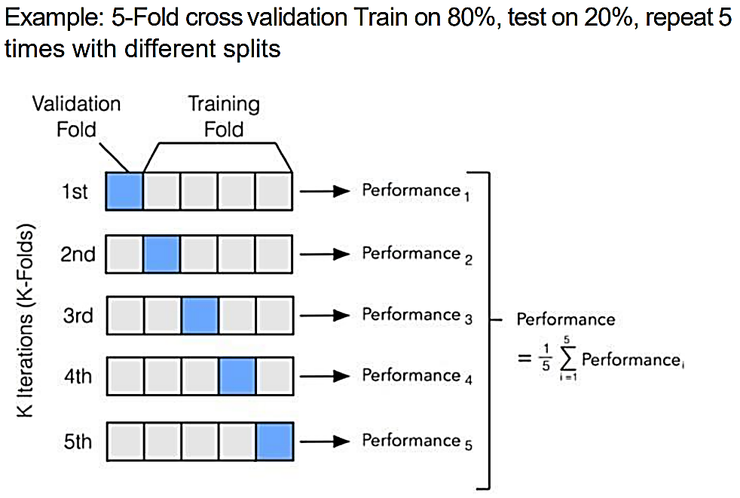
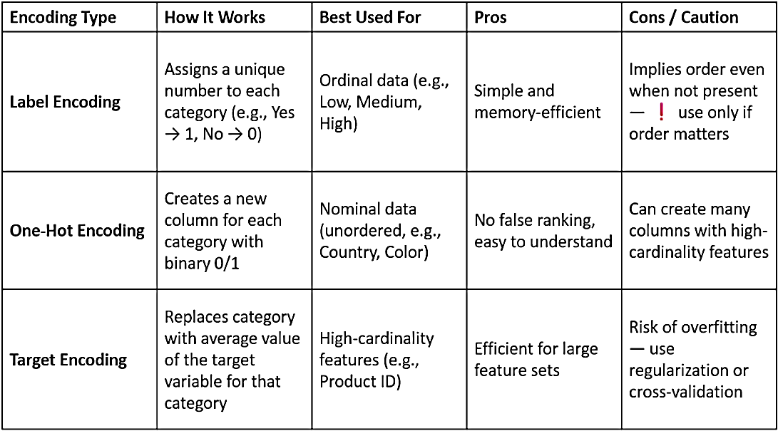
ML Pipeline: Sequence of steps which Raw data → Valuable predictions using ML techniques; It helps automate & streamline: Data flow; Model building; Evaluation; Deployment; Key stages: ¹Problem Definition: Understanding domain; Identifying Business Objective; Determining ML task type; ²Data Collection: Gather raw data from sources like sensors, websites, databases, files; Structured: Tabular format, easily searchable (databases, csv files); Unstructured: Free-form text, images, audio (social media); Sources of Data: APIs (OpenWeatherMap); Databases (SQL); Files (CSV); Data Acquisition Tools: Web scraping (BeautifulSoup, Scrapy); API clients (Postman, Python Requests); ETL tools (Apache NiFi, Talend, Airbyte); ³Data Preprocessing: Clean, fix & format data – remove nulls, encoding categorical features, scale numbers, normalization/standardization, data reduction, data transformation; Steps: Handling Missing Data: Fill w. average (mean imputation); Median imputation; Fill w. 0 or unknown; Drop the row (if too many values missing); Converting Categorical Data: Converting categories like Yes/No or Male/Female → numbers; Scaling the Data: Imagine Age ranges from 10–80 but Marks range from 0–10. The machine may give more attention to bigger numbers; Scaling ensures all features are treated equally; Common Methods: Min-Max Scaling (Rescales values between 0 & 1); $\frac{X-X_{min} }{X_{max }-X_{min}}$; Standardization (Z-score); $\frac{x-μ}{σ}$; Data Cleaning: Incomplete: Lacking attribute values, lacking certain attributes of interest/containing only aggregate data; Occupation=“ ” (missing data); Noisy: Containing noise, errors/outliers; Salary=10 (an error); Inconsistent: Containing discrepancies in codes/names; Age=42, Birthday=03/07/2010; Was rating 1, 2, 3, now rating A, B, C; Discrepancy between duplicate records; Intentional (Disguised missing data): Jan. 1 as everyone’s birthday? ⁴Feature Engineering (create & transform features that help model learn better): Process of raw data → meaningful features; Picking right features; Improving it; Removing unnecessary parts; Features: Information we use to help the machine make decision (columns in dataset); Features → Target; Some features aren’t helpful, confusing, hidden; Steps: Cleaning & Preparing data: Fill missing values; Convert text to numbers; Feature Selection: ¹Variance Threshold: Removes all features w. low variance (features that don’t vary much across samples & thus carry little information); Key Idea: Feature w. 0 or near 0 variance is likely constant/almost constant & not helpful for prediction; If a column has almost same value for everyone, it’s not useful; How it works: Calculates variance of each feature; Removes features where variance < user-defined threshold (default = 0); Suitable for numerical data; ²Mutual Information: Measures the amount of information shared between feature & target variable; High mutual information means knowing the feature helps predict the target; Key Idea: Unlike correlation (which captures only linear relationships), mutual information captures any kind of dependency (linear or non-linear); How it works: Estimate how much information a feature gives about target; Scores range from 0 (no info) – 1 (perfect info); Works for both categorical & numerical data; Very useful when target is non-linear w. input features; ³SelectKBest/Select Percentile: General-purpose selection wrappers that choose top K features (or top X percentile) based on a scoring function; Scoring Functions: Chi-square; Mutual information; ANOVA F-value; How it works: Calculate a univariate score for each feature using a statistical test; Select top K features (or top X%); Works w. classification/regression; Quick filtering based on relevance; ⁴Model-Based Selection: Uses a machine learning model to determine the importance of features, then selects based on importance scores; Some models (like decision trees & ensembles) internally compute feature importance during training; How it works: Train a model (Random Forest); Access feature importances attribute; Remove features w. low importance; Feature Selection Processes: ¹Filter Methods: Select features based on statistical tests & intrinsic properties of data — independent of any machine learning algorithm; Characteristics: Fast & computationally efficient; Useful for preprocessing large datasets; Not tailored to a specific model;
Technique | Description | Suitable For
Variance Threshold | Removes features w. low variance | Numerical features
Correlation Coefficient | Select features based on correlation w. target | Linear relationships
Chi-Square Test | Measures independence between categorical variables & target | Classification (categorical)
ANOVA (F-test) | Compares variance between groups | Classification problems
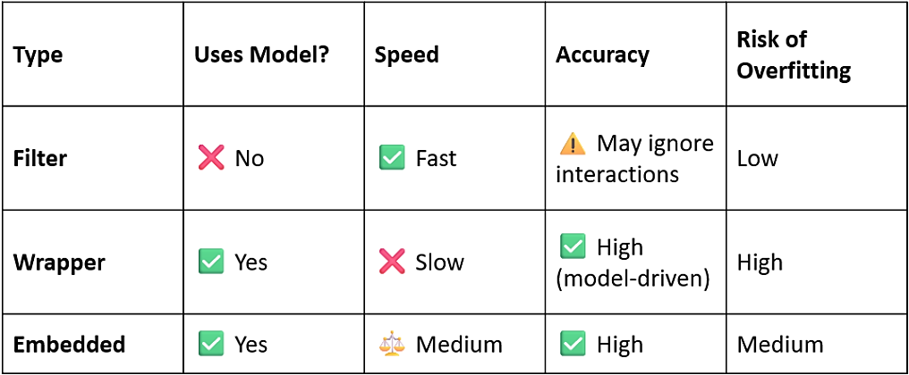
²Wrapper Methods: Evaluate different combinations of features using a predictive model; Performance (accuracy, RMSE) determines which features to keep; Characteristics: More accurate than filter methods; Computationally expensive; Prone to overfitting if not carefully tuned; ¹Forward Selection: Start w. no features, add 1 at a time based on performance; ²Backward Elimination: Start w. all features, remove 1 at a time; ³Recursive Feature Elimination (RFE): Recursively fits model & removes least important feature; ³Embedded Methods: Feature selection is integrated within model training process; Model itself selects the important features during learning; Characteristics: Balance between performance & computational cost; Model-specific; Automatically selects features during training;
Technique | Description | Applicable Models
Lasso Regression (L1 regularization) | Shrinks some coefficients to 0 | Linear Models
Decision Tree Feature | Selects features based on impurity reduction (Gini) | Trees, Random Forest
Elastic Net | Combines L1 & L2 regularization | Linear Models
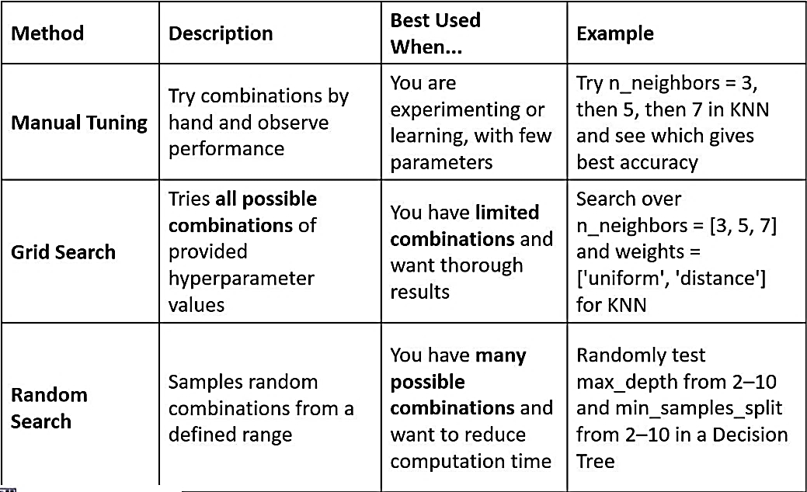
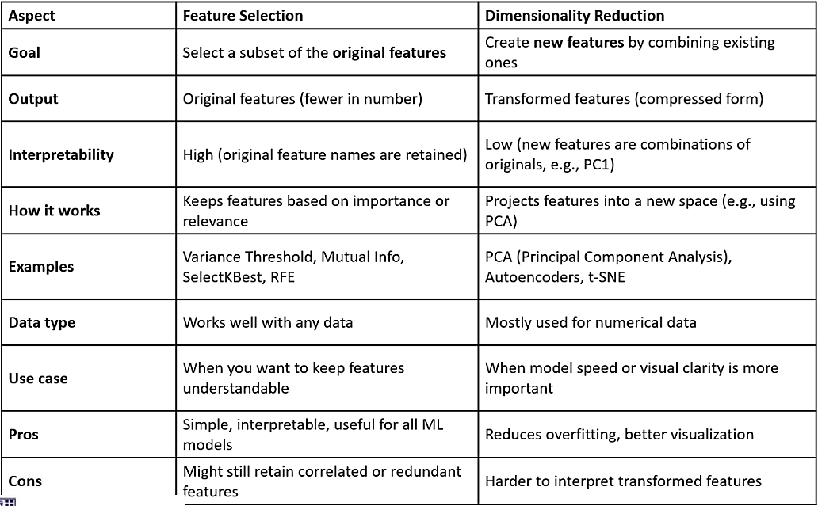
Dimensionality Reduction: Combining/removing features, keeping only what’s essential; When we have too many features, it’s like giving the machine too many things to think about, some may even confuse it; PCA (Principal Component Analysis): Think of it as squeezing a big photo into a smaller one, but still keeping the important parts visible; ⁵Model Selection: (choose right algorithm – decision tree, logistic regression); Model: Like a recipe/formula the computer learns from data to make predictions; Factors to consider: What is the problem type? (Classification, Regression, Clustering); How much data do you have? Do you need the model to be explainable? Do you prefer accuracy/speed? ⁶Model Training: (teach model to learn from data using the selected algorithm); Cleaned & Engineered Data → Training Set (80%) + Test Set (20%) → Model tries to understand patterns between features & target; Hyperparameter Tuning: Parameter: Learned by model from data (weights in linear regression); Hyperparameter: Setting that you define before training the model; knobs you can tune to improve model performance; E.g.: Decision Tree (max_depth, min_samples_split); K-Nearest Neighbors (n_neighbors, metric); SVM (kernel, C, gamma); Random Forest (n_estimators, max_features); Why tune hyperparameters? Improve model performance; Avoid overfitting/underfitting; Make model faster & more efficient; Cross Validation: Single train/test split might give a lucky/unlucky result; Cross-validation helps check if your model performs consistently; It splits data into & tests model more than once; Techniques: K-fold; Stratified K-Fold; Leave-One-Out (LOO); Benefits: Multiple tests (more stable & fair evaluation); Works on small data (makes most of limited data); Reduces overfitting (prevents tuning to one test data); K-Fold Cross-Validation: Split data into $K$ equal parts (called folds); Train on $K-1$ folds, test on the $1$ remaining; Repeat $K$ times, each time changing the test fold; Calculate average score = more reliable performance estimate; ⁷Model Evaluation: (measuring how well the model performs using test data – accuracy, error metrics); Model that performs well on training data might fail on new data, that’s why we evaluate using unseen test data;
Type | Metric | Interpretation
Classification | Accuracy | Overall correctness
Classification | Precision | Correctness of positive predictions
Classification | Recall | Coverage of actual positives
Classification | F1 Score | Balance between P & R
Regression | MAE | Avg. absolute error
Regression | MSE | Avg. squared error
Regression | R² Score | % variance explained
Good model: Learns patterns from training data; Generalizes well to new (unseen) data; Makes accurate predictions — not just memorizing; Overfitting: Model learns too much, including noise & outliers in training data; Too complex — tries to fit everything perfectly; Performs well on training data, but poorly on test data; Training accuracy ↑ Validation accuracy ↓; How to fix: Use simpler model (avoid high-complexity algorithms); Regularization (adds penalty for large weights); More training data (helps generalize better); Early stopping (stop training before it overlearns); Cross-validation (helps detect overfitting early); Underfitting: Model doesn’t learn enough from training data; Too simple — can’t capture patterns; Performs poorly on both training & test data; Training accuracy ↓ Validation accuracy ↓; How to fix: Use more complex model (try decision trees, ensembles); Add features (give more useful info); Reduce regularization (too much penalty can cause underfitting); Train longer (let model learn more patterns); ⁸Model Deployment: (make the model available in real world – app/website); Components of Model Deployment: Trained model file (.pkl, .joblib / .h5 model file); Prediction script (python script that loads the model & runs predictions); API/Interface (allows users to interact – web form, chatbot); Host environment (where the model runs – server, cloud, browser); Post-Deployment: Monitor model performance (accuracy may drop over time); Handle user feedback & bugs; Update model with new data (retraining);
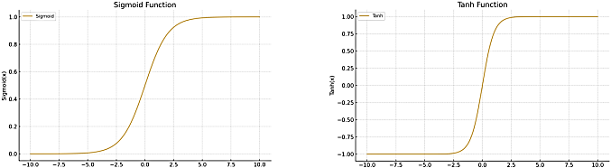
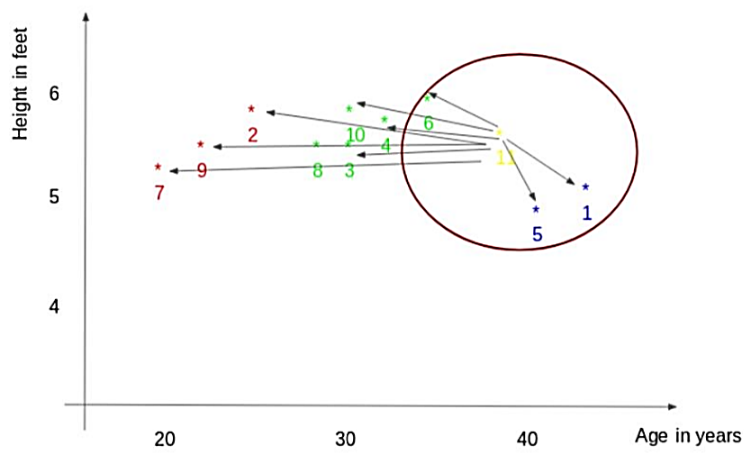
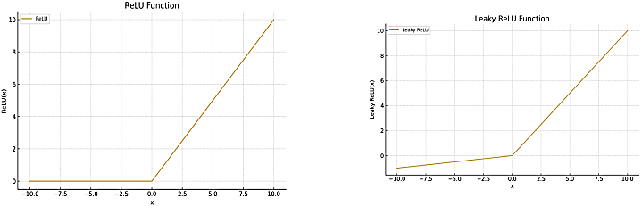
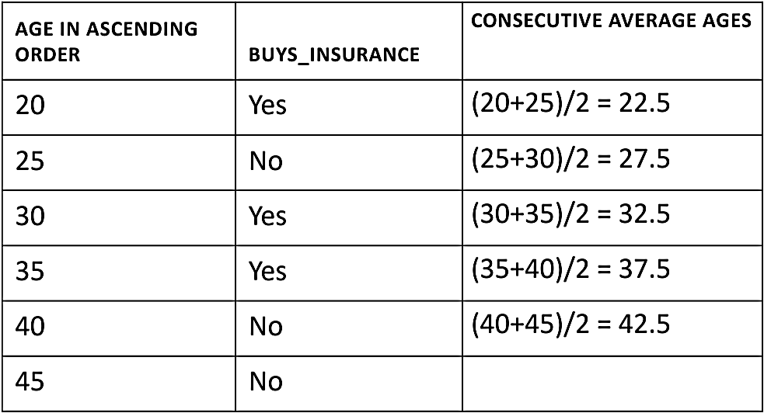
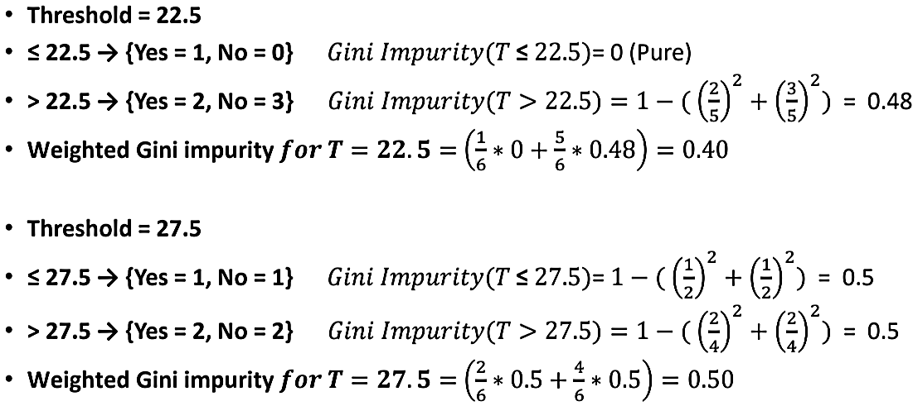
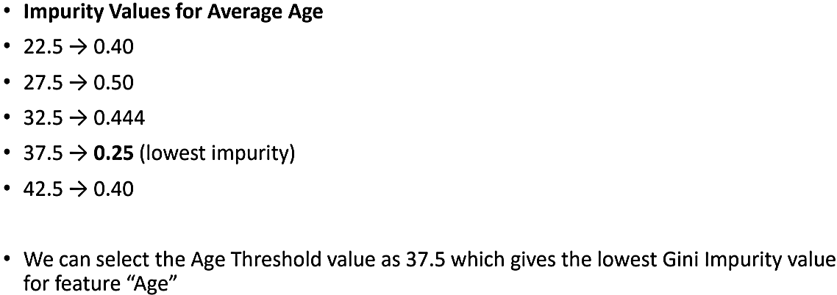
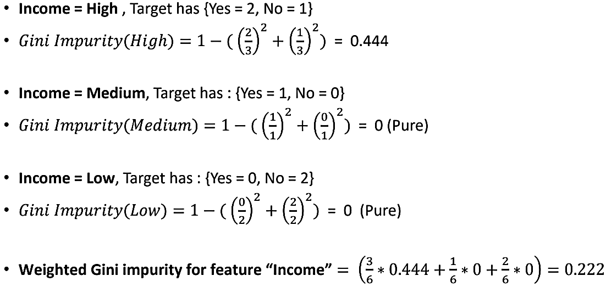
Supervised Learning: Model is trained on labeled dataset (input data is paired w. correct output); Goal: Learn the mapping between inputs & outputs so it can make accurate predictions on new, unseen data; ¹Linear Regression: Linear model (assumes a linear relationship between input variables $x$ & the single output variable $y$); Ordinary Least Squares (finds $β_{0}$ & $β_{1}$ analytically using calculus) technique is used to prepare/train linear regression equation from data; Model prepared this way → Ordinary Least Squares Linear Regression/Least Squares Regression; Key Assumptions: Linearity (relationship between $x$ & $y$ must be approximately linear); Normality (residuals should be approximately normally distributed; check w. histogram/Q-Q plot); Independence; No Multicollinearity; Homoscedasticity (residuals should’ve constant variance across all $x$ values; fan-shaped residual plot = violation); When to use: Predicting continuous values (prices, temperatures); Quick baseline model; Understanding feature-target relationships; When data shows a roughly linear trend; Econometrics & financial forecasting; A/B test analysis; Strengths: Simple, fast & interpretable; Coefficients explain feature importance; Low computational cost; Foundation of advanced models; Weakness: Can’t capture non-linear patterns; Sensitive to outliers; Assumes constant variance (homoscedasticity); Multicollinearity degrades performance; Extrapolation is unreliable; Simple Linear Regression: Single input variable ($x$); Relationship between 2 variables → Predictor/Independent Variable ($x$) & Response/Dependent Variable ($y$); Core idea: Obtain a line that best fits the data; Minimize total squared prediction error (SSE) across all data points; Best fit line: Line for which total prediction error (all data points) are as small as possible; $\hat{y}=β_{0}+β_{1}x+ε$; $y$ – Predicted value; Values $β_{0}$ and $β_{1}$ must be chosen so that they minimize the error; $β_{1}=\frac{∑\left(x_{i}-\overline{x}\right)\left(y_{i}-\overline{y}\right)}{∑{\left(x_{1}-\overline{x}\right)}^{2}}$ = Covariance/Variance (How do $x$ & $y$ move together/how spread out $x$ is); $β_{0}=\overline{y}-β_{1}\overline{x}$ → Always passes through data center point (x̄, ȳ); Extrapolation: Beyond dataset range; Techniques for estimating regression coefficients: Bayesian Regression; Kernal Regression; Ordinary Least Square (OLS); Measuring Error: Coefficient of Determination ($R^{2}$): Measures what fraction of variation in $y$ our model explains (how much of the variation of data, captured by this model); $R^{2}=1-\left(\frac{SSE}{TSS}\right)=\frac{TSS-SSE}{TSS}=\frac{SSR}{SST}$; $R^{2}=0$ (useless); $R^{2}=1$ (perfect fit; overfitting risk); Total Sum of Squares (TSS) = $∑{\left(y_{i}-\overline{y}\right)}^{2}$; Sum of Squared Errors (SSE) = $∑{\left(y_{i}-{\hat{y}}_{i}\right)}^{2}$; $y_{i}$ – Actual value; How much variation our model failed to explain; Leftover noise after fitting the line; Mean Squared Error (MSE) = $\frac{1}{n}∑{\left(y_{i}-{\hat{y}}_{i}\right)}^{2}$; Penalizes large errors heavily; Lower = Better; Root Mean Squared Error (RMSE) = $\sqrt{MSE}$; Same units as $y$; Mean Absolute Error (MAE) = $\frac{1}{n}∑\left|y_{i}-{\hat{y}}_{i}\right|$; Less sensitive to outliers than MSE/RMSE; Multiple Linear Regression: Multiple “”; Consider we have $k$ independent variables, $\hat{y}=β_{0}+β_{1}x_{1}+β_{2}x_{2}+…+β_{k}x_{k}+ε$; Always there’s a prediction error in both; ²Logistic Regression: Categorical (qualitative) variable; Dichotomous Responses/Binary Responses (responses w. 2 classes – yes/no); Linear Regression → Straight Line; Logistic Regression → Sigmoid Curve; Output of the model is the probability of belonging to the category; Have to convert $y$ → output is (+)ve, $0≤x≤1$ → Sigmoid fn^{c} → $S\left(x\right)=\frac{1}{1+e^{-x}}$; $σ\left(\hat{y}\right)=\frac{1}{1+e^{-\hat{y}}}=\frac{1}{1+e^{-\left(β_{0}+β_{1}x_{1}+β_{2}x_{2}+…+β_{p}x_{p}\right)}}$; When $\hat{y}=0$ → Decision Boundary/Cutoff Value (0.5); Logit → $\log\left(\frac{P}{1-P}\right)=β_{0}+β_{1}x_{1}+β_{2}x_{2}+…+β_{p}x_{p}$; Parameters of model ($β_{0}, β_{1}$) will be estimated using Maximum Likelihood Estimation; When predicting some variable using this model, a score will be given through this & probability should be found & then w. that probability according to some cutoff value, prediction will be done; P ≥ Some cutoff → Assign to class 1; P < Some cutoff → Assign to class 2; Generally, this cutoff values is 0.5 in most cases; But this can be changed according to situation; ³K Nearest Neighbors (KNN): Classification & Regression; Looks at nearest data points & decide based on them (distance between query point & other data points); Euclidean Distance: $d=\sqrt{{\left(x_{2}-x_{1}\right)}^{2}+{\left(y_{2}-y_{1}\right)}^{2}+{\left(z_{2}-z_{1}\right)}^{2}}$; Straight line distance between 2 points in Euclidean Space (space where it obeys principles of classical geometry); Closest $k$ data points are selected (based on distance); If we have a classification case, the most frequent category will be chosen to assign; To select optimum $k$ for the algorithm, hyperparameter optimization can be used; Small $k$: Captures local patterns; Very flexible, jagged boundary; Sensitive to noise/outliers; Bias ↓ Variance ↑; Overfit; Large $k$: Smoother decision boundary; More robust to noise; May miss local clusters; Bias ↑ Variance ↓; Underfit; ⁴Classification & Regression Trees (CART) – Decision Trees: Non-parametric; Tree of multiple decision rules, all these rules will be derived from data features; It’s the most fundamental components of Random Forest; Classification tree: Root Node (training dataset) → Internal Node (subgroup splits to new sub-group/leaf node) → Leaf Node (predictive/dependent/target variables – holds the decision); Internal node represents a segment/region; Segments/Regions are nodes/leaves of tree; Splitting of one node to another happens based on a threshold value of an attribute; Splitting like tree → Recursive partitioning; How it works: Root Node → Find best split (evaluate each feature – pick one that best separates classes) → Split data (divide data into subgroups based on best feature’s values) → Repeat steps 2, 3 for each child node → Stop when: Node is pure, max depth reached, or too few samples remain; Splitting of node (root node) to sub-nodes happens based on purity (where it will find best homogeneity for sub-nodes); If a Sub-node has all its class members then homogeneity will be ↑; If Sub-node has 5/5 class member distribution then homogeneity will be ↓ & highest in case it is 8/2 or 9/1; To split a node, Decision Tree algorithm needs best attribute & threshold value (attribute → age < 30 ← threshold value); Algorithms which helps to find measurements of best attributes: CART algorithm (Gini Index); ID3 algorithm (Information Gain); C4.5 algorithm (Gain Ratio); Gini Index (Gini impurity): Measure of how mixed/impure a dataset is; Ranges between 0 – 1; 0 – Pure dataset (all samples belong to same class/category; considered ideal – can be easily divided); 1 – Completely impure dataset (mixture of different classes/categories; difficult to divide); $1-∑\left(p{\left(i\right)}^{2}\right)$; $∑\left(p\left(i\right)⋅\left(1-p\left(i\right)\right)\right)$; $1-{\left(p\left(yes\right)\right)}^{2}-{\left(p\left(no\right)\right)}^{2}$; $p\left(i\right)$ – Probability of a specific class; Summation is done for all classes present in dataset; We want to determine the best feature to use as root node for decision tree (for that, we will calculate Gini impurity); Confusion matrix: Left (Actual true/false); Top (Predicted true/false); TP (predicted & actual positive); TN (predicted & actual negative); FP (predicted positive, actual negative); FN (predicted negative, actual positive); Accuracy = $\frac{TP+TN}{TP+TN+FP+FN}=\frac{correct predictions}{total predictions}$; Precision = $\frac{TP}{TP+FP}=\frac{True positive}{Positives}$; Recall = $\frac{TP}{TP+FN}=\frac{True positive}{Actual positives}$; F1 = $2×\frac{Precision×Recall}{Precision+Recall}=\frac{2TP}{2TP+FP+FN}$ Harmonic mean of precision & recall; Regression tree: For best splits, Reduction in Variance method can be used; ⁵Support Vector Machines:
$$k=3$$
Average of these data points is the final prediction for the new point
$$\frac{77+72+60}{3} = 69.66 kg$$

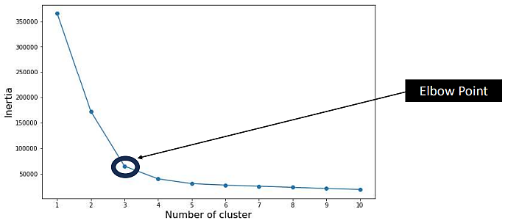
Unsupervised Learning: Type of machine learning where the algorithm is trained on unlabeled data (data doesn’t come w. predefined outputs/categories); System tries to discover hidden patterns, structures/relationships within the data on its own; K-Means Clustering: Algorithm used for data segmentation & grouping similar data points into clusters (e.g.: data analysis, image processing & customer segmentation); $K$- # of clusters; Steps of K-Means Clustering: Initialization: Start by selecting $K$ initial centroids randomly; Assignment: Assign each data point to the nearest centroid; This is done by calculating Euclidean distance between each data point & each centroid; Data point is assigned to the cluster w. the nearest centroid; Update Centroids: Recalculate the centroids of each cluster by taking the mean of all data points assigned to that cluster; These new centroids represent the updated cluster centers; Repeat: Steps 2 & 3 are repeated iteratively until one of the stopping criteria is met (Centroids of newly formed clusters do not change; Points remain in the same cluster; Maximum number of iterations are reached);
Selecting K: Consider several values for $K$ & find the inertia values for each $K$;
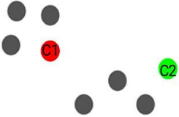
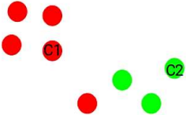
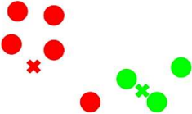
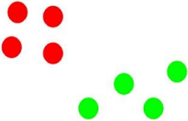
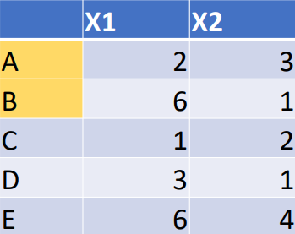
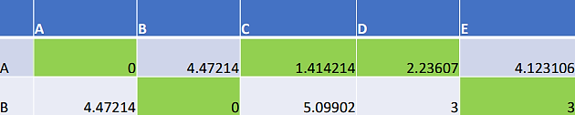
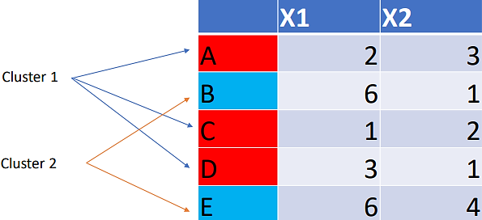
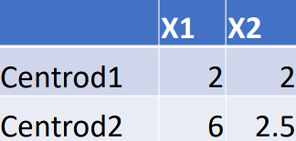
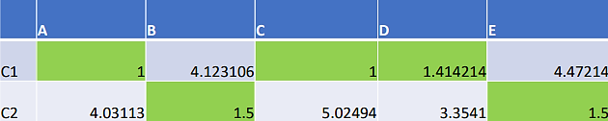
Metrics used for evaluating clusters (accuracy of the unsupervised learning): Inertia (Calculates sum of distances of all points within a cluster from centroid of that cluster); $\sum_{points in cluster}{{\left(Euclidean distance to centroid\right)}^{2}}$; Measures how tightly packed each cluster is; Dunn Index (Considers distance between two clusters); $\frac{\min\left(inter cluster distance\right)}{max⁡(intra cluster distance)}$; Hierarchical Clustering: Data analysis technique that organizes data objects into a tree-like structure based on their similarity; Important in biology, social sciences & image analysis, for identifying hierarchical relationships within data, which can aid in understanding groupings, taxonomy & decision-making based on data similarities; Agglomerative: Bottom Up (mostly used one); Accumulating; Divisive: Top Down; Breaking down; Other Clustering Methods: DBSCAN (Density-Based Spatial Clustering of Applications w. Noise): Groups together points that are densely packed; Can find arbitrarily shaped clusters; Identifies outliers (noise points); E.g.: Detecting unusual customer spending patterns; OPTICS (Ordering Points To Identify the Clustering Structure): Extension of DBSCAN; Handles clusters of varying density better; Builds a cluster ordering rather than fixed clusters; Mean Shift Clustering: Finds peaks (high-density regions) in data; Doesn’t need the # of clusters in advance; Useful for image segmentation & feature analysis; Gaussian Mixture Models (GMMs): A probabilistic model where each cluster is assumed to follow a Gaussian (normal) distribution; Provides soft clustering (a point can belong partly to multiple clusters); E.g.: Speaker recognition, customer segmentation; Spectral Clustering: Uses graph theory & eigenvalues of a similarity matrix; Very powerful for non-convex clusters; E.g.: Social network analysis; BIRCH (Balanced Iterative Reducing & Clustering using Hierarchies): Handles large datasets efficiently; Builds a tree structure (CF tree) & clusters data incrementally;
First choose 2 random points from these points (Assume $K=2$)
Calculate the Euclidean Distance from the selected points to each point separately
Find new centroids by calculating the average of coordinates
Same clusters have been found (and the same centroids), then stop
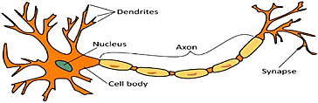
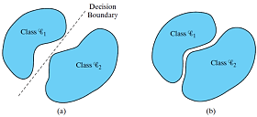
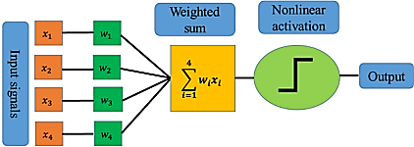
Deep Learning: Way for computers to learn patterns & make decisions (like human brain); Traditional ML: Algorithms need you to manually select features (detecting edges in an image); Deep Learning: Learns features automatically (finds eyes, nose & face w/o explicit coding); Neural Network: Computational model inspired by the way biological neural networks in human brain process information; Made up of layers of interconnected nodes/neurons; Neuron (node): Smallest processing unit; Layer: Input Layer → raw data enters; Hidden Layer(s) → where learning happens; Output Layer → final prediction; Weights: Strength of connection between neurons; Bias: Adjustment term; Adjusts output up/down along the y-axis; Activation Function: Adds non-linearity (so network can solve complex problems); Classification problems: Binary classification: 2 class labels (spam/not spam); Multi-class classification: >2 class labels (hand-written character recognition); Perceptron (first neural network): Simplest form of neural network; Earliest types of artificial neurons introduced by Frank Rosenblatt (1958); Binary classifier; Takes several binary/real-valued inputs, applies weights to them, sums the results, adds a bias & then passes the result through an activation function (usually a step function); $y=1$ if $\left(w⋅x+b\right)≥0$, else $0$; $u_{k}=\sum_{j=1}^{m}{w_{kj}}x_{j}$; $v_{k}=u_{k}+b_{k}$; $y_{k}=ϕ(u_{k}+b_{k})$; 1 Single Perceptron: Linearly separable (patterns that lie on opposite sides of hyperplane); Multiple Perceptron together: Non-linear separable data; The two classes $C_{1}$ & $C_{2}$ are sufficiently separated from each other for us to draw a hyperplane (in this case, a straight line) as the decision boundary; If, however, the 2 classes $C_{1}$ & $C_{2}$ are allowed to move too close to each other, as in (b), they become nonlinearly separable, a situation that is beyond computing capability of the perceptron; Perceptron consists of a single neuron w. adjustable synaptic weights & bias; The algorithm used to adjust the free parameters of this neural network first appeared in a learning procedure developed by Rosenblatt (1958, 1962) for his perceptron brain model; Rosenblatt proved that if the patterns (vectors) used to train the perceptron are drawn from two linearly separable classes, then the perceptron algorithm converges & positions the decision surface in the form of a hyperplane between the two classes; Proof of convergence of the algorithm – perceptron convergence theorem (presented w/o reference to a cost function); Derivation focused on a single-sample correction; In each epochs, weights are updated; $y\left(n\right)$ actual response; $d\left(n\right)$ desired response; $η$ – learning-rate parameter; Hyperparameter that controls the speed which a neural network learns; $0<η<1$; Initialization: Set $w\left(0\right)=0$, setting the weights as 0; $X\left[0\right]=\left[\begin{matrix}bias \\ X_{1} \\ X_{2}\end{matrix}\right], W\left[0\right]=\left[\begin{matrix}0 \\ 0 \\ 0\end{matrix}\right]$; $v=w^{T}X={\left[\begin{matrix}0 \\ 0 \\ 0\end{matrix}\right]}^{T}\left[\begin{matrix}bias \\ X_{1} \\ X_{2}\end{matrix}\right]=\left[\begin{matrix}0 & 0 & 0\end{matrix}\right]\left[\begin{matrix}bias \\ X_{1} \\ X_{2}\end{matrix}\right]=0$; $y\left(n\right)=sgn[w^{T}\left(n\right)x\left(n\right)]$; $n$ – time-step; $sgn\left(x\right)=\left\{\begin{matrix}+1 & \text{if }x>0 \\ 0 & \text{if }x=0 \\ -1 & \text{if }x<0\end{matrix}\right.$; $sgn\left(x\right)$ – signum function; $y\left(0\right)=sign\left(0\right)=0$; $w'=w+η\left[d-y\right]x$; $b'=b+η\left[d-y\right]1$; Weight increment: $Δw_{j}=η\left(d-y\right)x_{j}$; $w_{j}^{'}=w_{j}+Δw_{j}$; Error value: $d\left(n\right)-y(n)$; Error factor: $η(d-y)$; $w_{n+1}=w_{n}+η\sum_{x∈X}{x_{n}d_{n}}$; Batch Perceptron Algorithm: Generalized form of a perceptron cost function; Use the cost function to formulate a batch version of the perceptron convergence algorithm; Misclassified Samples: $y_{n}⋅d_{n}<0$; $y_{n}$ & $d_{n}$ will be the opposites; Correct Samples: $y_{n}⋅d_{n}>0$; Cost function: $J\left(w\right)=-\sum_{x∈X}{w_{\left(n\right)}^{T}}x_{\left(n\right)}d_{\left(n\right)}$; $X$ – Set of samples $x$ misclassified; If all samples are correctly classified, then the set $X$ would be empty & $J\left(w\right)$ would be 0; Differentiate $J\left(w\right)$ w. respect to $w$ gives the gradient vector: $∇J\left(w\right)=-\sum_{x_{\left(n\right)}∈X}{{(x}_{\left(n\right)}}d_{\left(n\right)})$; Weight adjustment method that we discussed above is called the method of steepest descent as the amount of adjustment depends on the steepness of the cost function (gradient); In order to reduce the cost function, we need to change the weights; Weight adjustment happens in the direction opposite to the gradient vector; Gradient vector – $∇J\left(w\right)$; $w\left(n+1\right)=w\left(n\right)-η(n)∇J\left(w\right)$; Limitations of Perceptron: Can’t solve problems where data isn’t linearly separable (XOR problem); Solution: Use Multi-Layer Perceptrons (MLP); Types of Neural Networks: Shallow neural networks: Usually have only 1 hidden layer; Fast & requires less processing power than deep neural networks; Can perform as many complex tasks as deep neural networks; Deep neural networks: Have multiple hidden layers; Feedforward Neural Network (FNN): Information moves in one direction—from input → hidden layers → output; Best for structured/tabular data; Basic classification (spam/not spam); Simplest type of neural network; No loops; Convolutional Neural Network (CNN): Uses filters (kernels) to scan through data, especially images & detect patterns like edges, shapes, or textures; Image recognition, video analysis, medical image analysis; Best suited for image & spatial data; Recurrent Neural Network (RNN): Has connections that loop back (remembers information from previous steps); Language modeling, text prediction, speech recognition, time-series forecasting; Good for sequential data where order matters; Long Short-Term Memory (LSTM) Networks: Special type of RNN that avoids the problem of ”forgetting” long sequences by using memory cells & gates; Built for sequences where order matters; Machine translation, chatbot responses, predicting stock prices; Designed to remember information for longer sequences; Generative Adversarial Networks (GANs): Made up of two networks—Generator (creates fake data) & Discriminator (checks if data is real or fake). They compete to improve; Creating realistic images, deepfakes, art, data augmentation; Good at generating new, realistic data; Self-Organizing Maps (SOMs): Unsupervised network that maps high-dimensional data into a lower dimension (usually 2D) for visualization; Data clustering, feature mapping, pattern recognition; Helps visualize complex data; Modular Neural Networks (MNNs): Splits a big problem into smaller parts, each solved by a separate network. Their results are combined at the end; Large, complex systems such as robotics or medical diagnosis; Breaks down complex problems into manageable modules; Multi-Layer Neural Networks: Advanced model used in AIML; Collection of interconnected perceptrons; Unlike a perceptron, which has only one layer of neurons, a multilayer neural network has multiple layers stacked on top of each other; Each layer receives input from previous layer & applies mathematical operation (activation function), such as the sigmoid function; Input Layer: 1st layer that takes in raw features from dataset (in image recognition, each pixel value is an input); Hidden Layers: Intermediate layers that transform inputs into useful representations Each hidden layer applies weights + biases + activation functions to the inputs; Deeper the layers, the more abstract patterns the network can learn; Output Layer: Produces final decision/prediction (Cat vs. Dog classification → probabilities like [0.9, 0.1]); How Neural Networks Learn: Forward Propagation (make a prediction): Data flows from input → hidden layers → output; Layer → layer (an image is processed layer by layer, from pixels to object recognition); Each neuron does a weighted sum, adds a bias, then applies an activation (e.g., ReLU/sigmoid); Outputs of one layer become the inputs to the next; Weighted sums & activation functions determine neuron outputs; For layer 1: Weight ($W^{1}$); Bias ($b^{1}$); Pre-activation: $z^{1}=W^{1}a^{1-1}+b^{1}$; Activation: $a^{1}=f(z^{1})$; Output layer: Binary classification: $\hat{y}=σ(z)$; Multi-class: $\hat{y}=softmax(z)$; Loss Function: Measures error between prediction & actual answer; Compare prediction $\hat{y}$ w. true label $y$; Loss is a single number to minimize; Binary cross-entropy (BCE) for 2 classes: $L=-[y\log\left(\hat{y}\right)+\left(1-y\right)\log\left(1-\hat{y}\right)]$; Categorical cross-entropy (CE) for $K$ classes: $L=-\sum_{k=1}^{K}{y_{k}log⁡({\hat{y}}_{k})}$ (w. one-hot $y$); MSE (regression): $L=\frac{1}{n}\sum{{\left(\hat{y}-y\right)}^{2}}$; Backpropagation: Error is sent backward to update weights; Uses Gradient Descent to minimize error step by step; Training: Repeat forward + backward many times until the network learns;

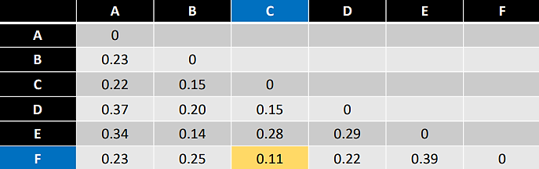
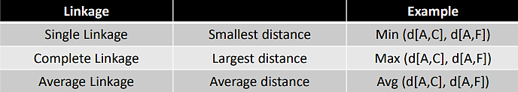
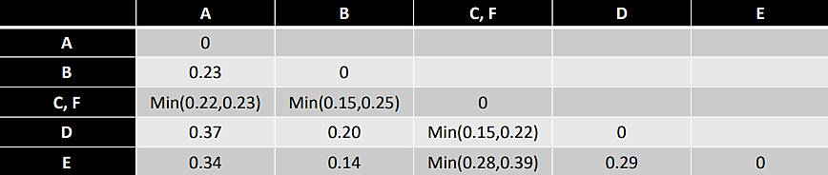
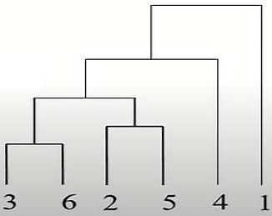
Bias in AI/ML: Systematic unfairness in data/algorithms that leads to discriminatory outcomes; When an algorithm produces results that are systematically prejudiced due to assumptions made in ML process; Unlike random errors, bias is consistent & can amplify social inequalities if left unchecked; Data Bias: Historical data may reflect social prejudices (women underrepresented in tech datasets); Sampling Bias: Training data doesn’t represent the diversity of population (healthcare AI trained only on Western patients performs poorly for Asian populations); Labeling Bias: Human annotators who prepare data for AI introduce their own subjective opinions or stereotypes while tagging/categorizing that data (“Aggressiveness” in criminal datasets may reflect stereotypes rather than reality); Algorithmic Bias: Model design choices inadvertently favor majority classes (facial recognition system optimized for accuracy may underperform on minority groups); Interaction Bias: User feedback reinforces stereotypes (search engines/recommendation systems amplifying harmful content because of click patterns); Consequences of Bias: Individual harm: Denial of loans, jobs, or healthcare; Societal harm: Reinforcement of stereotypes & social inequality; Loss of trust: People resist adopting AI systems perceived as unfair; Legal risk: Companies face lawsuits/regulatory penalties; Ethics “”: Ensures that AI is aligned w. human values; Provides moral & philosophical principles that guide the design, development & deployment of these technologies; Core Ethical Principles in AI: Fairness: Systems must treat individuals & groups equitably; Avoid direct & indirect discrimination; Transparency & Explainability: Users should understand how decisions are made; “Black-box” models create accountability gaps; Accountability: Responsibility must be clear if an AI system causes harm; Involves both developers & organizations; Privacy & Data Protection: Secure handling of sensitive personal information; Compliance w. frameworks like GDPR; Human Oversight: Humans must remain in control of critical systems (healthcare, military); Safety & Security: AI must be robust against errors, adversarial attacks & misuse; Beneficence & Non-Maleficence: Promote well-being, avoid harm; Bias & Ethics (intersection): Together, they determine whether AI systems benefit humanity fairly/perpetuate inequality; Ethical AI requires bias detection, bias mitigation & fairness-aware design; Strategies for Addressing Bias & Promoting Ethics: Technical Solutions: Fairness-aware algorithms: Modify models to account for fairness constraints; When building models, setting constraints, so that it can’t make unfair decisions; Bias detection tools: Regular audits to identify hidden discrimination; Balanced datasets: Ensure diversity & representation in training data; Explainable AI (XAI): Provide interpretable results to reveal unfair outcomes; Being transparent about why it came to that decision; Organizational & Policy Approaches: AI Ethics Boards: Internal committees for oversight (monitoring AIs); Model Cards/Datasheets for Datasets: Documentation that improves transparency; Adoption of Guidelines: OECD, UNESCO, and EU “Trustworthy AI” standards; Interdisciplinary Collaboration: Involving ethicists, domain experts & end-users; Case Studies: COMPAS Algorithm (US criminal justice): Criticized for racial bias in predicting recidivism; Used in U.S. courts for parole decisions; Found to disproportionately classify Black defendants as “high risk”; Amazon Recruitment AI: Designed to automate hiring but penalized female candidates due to historical male-dominated data; Ethical failure: Lack of fairness & accountability;
This process is continued until 0 is reached
Dendrogram

